**KONFIGURASI DHCP PADA VLAN DENGAN CISCO PACKET TRACER**

**1.       Beri nama vlan seperti berikut di switch**

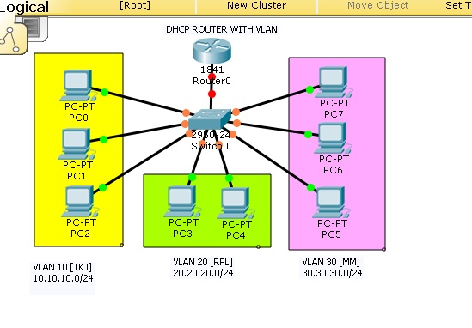

Switch>en

Switch#conf t

Enter configuration commands, one per line. End with CNTL/Z.

Switch(config)#vlan 10

Switch(config-vlan)#name TKJ

Switch(config-vlan)#vlan 20

Switch(config-vlan)#name RPL

Switch(config-vlan)#vlan 30

Switch(config-vlan)#name MM

Switch(config-vlan)#exit

Switch(config)#int fa0/1

Switch(config-if)#switchport mode trunk

Switch(config-if)#end

**2.      Access vlan ke port interface**

Switch#conf t

Enter configuration commands, one per line. End with CNTL/Z.

Switch(config)#int fa0/2

Switch(config-if)#switchport mode access

Switch(config-if)#switchport access vlan 10

Switch(config-if)#int fa0/3

Switch(config-if)#switchport mode access

Switch(config-if)#switchport access vlan 10

Switch(config-if)#int fa0/4

Switch(config-if)#switchport mode access

Switch(config-if)#switchport access vlan 10

Switch(config-if)#int fa0/5

Switch(config-if)#switchport mode access

Switch(config-if)#switchport access vlan 20

Switch(config-if)#int fa0/6

Switch(config-if)#switchport mode access

Switch(config-if)#switchport access vlan 20

Switch(config-if)#int fa0/7

Switch(config-if)#switchport mode access

Switch(config-if)#switchport access vlan 30

Switch(config-if)#int fa0/8

Switch(config-if)#switchport mode access

Switch(config-if)#switchport access vlan 30

Switch(config-if)#int fa0/9

Switch(config-if)#switchport mode access

Switch(config-if)#switchport access vlan 30

Switch(config-if)#exit

Switch(config)#end

**3.       Pemberian  IP ADDRESS pada Router**

Router>en

Router#conf t

Enter configuration commands, one per line. End with CNTL/Z.

Router(config)#int fa0/0

Router(config-if)#no sh

Router(config-subif)#int fa0/0.10

Router(config-subif)#encapsulation dot1q 10

Router(config-subif)#ip add 10.10.10.1 255.255.255.0

Router(config-subif)#int fa0/0.20

Router(config-subif)#

%LINK-5-CHANGED: Interface FastEthernet0/0.20, changed state to up

%LINEPROTO-5-UPDOWN: Line protocol on Interface FastEthernet0/0.20, changedstate to up

Router(config-subif)#encapsulation dot1q 20

Router(config-subif)#ip add 20.20.20.1 255.255.255.0

Router(config-subif)#int fa0/0.30

Router(config-subif)#encapsulation dot1q 30

Router(config-subif)#ip add 30.30.30.1 255.255.255.0

Router(config-subif)#exit

Router(config)#end

**4.      Mengaktifkan konfigurasi DHCP seperti berikut**

Router#conf t

Enter configuration commands, one per line. End with CNTL/Z.

Router(config)#int fa0/0.10

Router(config-subif)#ip dhcp pool TKJ

Router(dhcp-config)#network 10.10.10.0 255.255.255.0

Router(dhcp-config)#default-router 10.10.10.1

      Route(dhcp-config)#dns-server 8.8.8.8

Router(dhcp-config)#ip dhcp excluded-address 10.10.10.1 10.10.10.2

Router(config)#exit

Router#

%SYS-5-CONFIG_I: Configured from console by console

Router#conf t

Router(config)#int fa0/0.20.

Router(config-subif)#ip dhcp pool RPL

Router(dhcp-config)#network 20.20.20.0 255.255.255.0

Router(dhcp-config)#default-router 20.20.20.1

Router(dhcp-config)#dns-server 8.8.8.8

Router(dhcp-config)#ip dhcp excluded-address 20.20.20.1 20.20.20.2

Router(config)#int fa0/0.30

Router(config-subif)#ip dhcp pool MM

Router(dhcp-config)#network 30.30.30.0 255.255.255.0

Router(dhcp-config)#default-router 30.30.30.1

Router(dhcp-config)#dns-server 8.8.8.8

Router(dhcp-config)#ip dhcp excluded-address 30.30.30.1 30.30.30.2

Router(config)#exit

**5.      Setelah semua di konfigurasi sekarang coba test yang hasilnya akan seperti dibawah ini :**

**6.      Ke PC lalu Desktop – IP Configuration lalu ubah static menjadi DHCP tunggu sebentar dan lihat hasilnya berhasil atau tidak.**

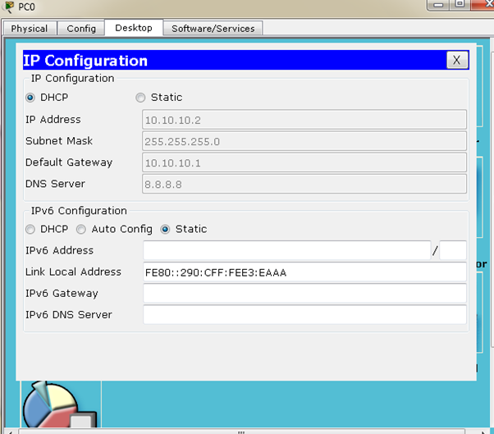

**7.      Jika tidak coba cek kembali konfigurasinya.**